(A typical Specimen of Cover Page & Title Page)



**Tribhuvan University**

**Faculty of Humanities and Social Sciences**

**TITLE OF PROJECT REPORT**

**A PROJECT REPORT**

**Submitted to**

**Department of Computer Application**

**Kathmandu College of Technology**

***In partial fulfillment of the requirements for the Bachelors in Computer Application***

Submitted by

Name: Dipesh Kumar Kushwaha

Roll No:- 02

Month and Year

Under the Supervision of

**Supervisor Name**

(A typical Specimen of Certificate)



**Tribhuvan University**

**Faculty of Humanities and Social Sciences**

**Kathmandu College of Technology**

**Supervisor’s Recommendation**

I hereby recommend that this project prepared under my supervision by DIPESH KUMAR KUSHWAHA entitled “**TITLE OF THE PROJECT……………..”** in partial fulfillment of the requirements for the degree of Bachelor of Computer Application is recommended for the final evaluation.

<<Signature of the Supervisor>>

**SIGNATURE**

<<Name>>

# SUPERVISOR

<<Academic Designation>>

<<Department>>

<<Full address of the Dept & College >>

(A typical specimen of Approval)



**Tribhuvan University**

**Faculty of Humanities and Social Sciences**

**College Name**

**LETTER OF APPROVAL**

This is to certify that this project prepared by DIPESH KUMAR KUSHWAHA entitled “**TITLE OF**  **THE PROJECT……………..”** in partial fulfillment of the requirements for the degree of Bachelor in Computer Application has been evaluated. In our opinion it is satisfactory in the scope and quality as a project for the required degree.

|  |  |
| --- | --- |
| **SIGNATURE of Supervisor**    Name and Academic designation  Department name and full address of the college | **SIGNATURE of HOD/ Coordinator**    Name and Academic Designation  Department name and full address of the college |
| **SIGNATURE of Internal Examiner**  **Internal Examiner** | **SIGNATURE of External Examiner**  **External Examiner** |

College Name

Ref No:

Date:

## Subject: Approval of Project Proposal

The project entitled “Hamro Job Center” proposed by Mr. and Mr. for the partial fulfillment of the requirement for Bachelor in Computer Application (BCA), fourth semester has been approved for further development.

**Proposal Evaluation Committee**

1. **_______________________**
2. **_______________________**
3. **_______________________**
4. **_______________________**

Mr.

Campus Chief (.)

Contents

Chapter 1 Introduction 6

1.1 Introduction of Proposed project 6

1.2 Problem Statement 6

1.3 Objectives 6

1.4 Scope and limitation 7

Chapter 2 Literature Review 8

Chapter 3 Methodology 9

3.1 System Analysis 9

3.2 System Design 11

3.3 Project Schedule 13

Chapter 4 Conclusion 14

Overall the management of job and the user will be done properly for the betterment of users. Job seekers can rely on this website to find the suitable jobs. They will also be given a proper feedback about choosing their job wisely. So, Hamro Job Centre Provides the better facilities for the job seekers 14

4.1 Expected Outcome 14

References 15

Bibliography 15

# Chapter 1 Introduction

## 1.1 Introduction of Proposed project

A job center is a place where people are looking for work and as to easily finding a job, and to look at advertisement or by internet placed by people who are looking for new employees.

Hamro Job Center is design to provide a full range of assistance to job seekers under one roof. The center offer training referrals, career counseling, job listings, and similar employment-related services. Customers can visit a center in person or connect to the center's information online.

The main focus of this Hamro Job Center is on the job-search practices of benefit claimants, with particular reference to those who are unemployed and try to change a job. However, job search is exclusive to the unemployed with easily search in a wider.

Job is an important factor and without work life is impossible. With job we can do everything, either fulfill our desires or family needs but the important one is we eventually attain confidence, self-respect & social status which makes us feel the part of society. Thus, Hamro Job Center helps further to make one individual self-dependent and successfully employed.

## 1.2 Problem Statement

In the context of Nepal, many job seekers have to face hurdles.

* A user doesn’t get the proper information about the job.
* Candidates get an automated response not a real person.
* Online applications take too long to fill out.
* Candidates who apply online are often ignored.

## 1.3 Objectives

The main object of this project is to provide information about the essential and suitable job for the seekers.

a. Provide all required details about the job.

b. Provide employment related services.

c. Give counseling for job seekers online.

d. Recommended the job nearby your location.

## 

## 1.4 Scope and limitation

**Scope**

1. Save time
2. Easy to update.
3. Reduce burden of tension.
4. You can get all kind of job as you want to do.
5. Any (Authorized, Guest) user can use this system.

**Limitation**

1. This system is used for online basis only as we provide you.
2. No handing for transaction between employer and admin( ex: Use of IME / any bank)
3. No email alerts are send to jobseeker about matching job, they have to login to the system for this purpose.
4. There is only one administrator account to manage the whole system.

# Chapter 2 Literature Review

For this project, we researched and reviewed some of the related websites and applications. Throughout the research, we get to find out that there are very few websites or applications related to online jobs. So, the users can’t get the quality information and suitable job.

If some website are available for users, we found the websites are looking many features regarding the job. Especially, the users are not convinced with the quality facilities given to them.

# Chapter 3 Methodology

We are going to use the waterfall methodology while building the website. This project have specific documentation, ample time, fixed requirements, well-understood technology so in order to build this system, water fall methodology can be used.

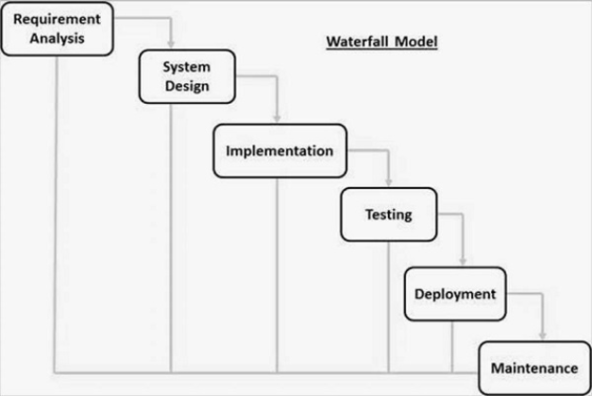

Fig: Waterfall Model

The Waterfall Model was the first Process Model to be introduced. It is also referred to as a linear-sequential life cycle model. It is very simple to understand and use. In a waterfall model, each phase must be completed before the next phase can begin and there is no overlapping in the phases. It is easy to arrange tasks and clearly defined stages.[1]

## 3.1 System Analysis

It is a process of collecting and interpreting facts, identifying the problems, and decomposition of a system into its components.

System analysis is conducted for the purpose of studying a system or its parts in order to identify its objectives. It is a problem solving technique that improves the system and ensures that all the components of the system work efficiently to accomplish their purpose. [2]

Requirements Identification:

This system needs to fulfill following functional and non-functional requirements.

* Functional Requirements:

1. Administrator will be able to check the user the user’s information.
2. Administrator will be verify users account give them right to access the right.
3. Users will be able to register and login.
4. User will be able to apply for job directly.

* Non- Functional Requirements:
  + - 1. **Availability:**

It will be available online.

* + - 1. **Security:**

This system will be secure and the users information won’t be available for others for users privacy.

* + - 1. **Performance:**

This system will be designed for smooth performance with optimization and good response.

* + - 1. **Reliability:**

It will be reliable for the user.

* 1. **Feasibility study**:

A **feasibility study** is an evaluation and analysis of a project or system that somebody has proposed. [3] Following feasibilities were studied before building the system to see if the system could be built with exact requirements in required time.

* Technical feasibility:

In order to design this system, it uses off-self and existing technologies, software and hardware so there is no technological hurdle to build this system.

* Economic feasibility:

The system does not require extra software and hardware i.e. it uses open-source technologies. So, there is no recurring cost than just the internet connection.

* Operational feasibility:

This system uses simple technologies to design. So, it is user friendly.

* 1. **Tools**
* Front end
* Html
* CSS
* JavaScript
* PHP
* Back end
* My SQL

## 3.2 System Design

* Administrator(Use Case)

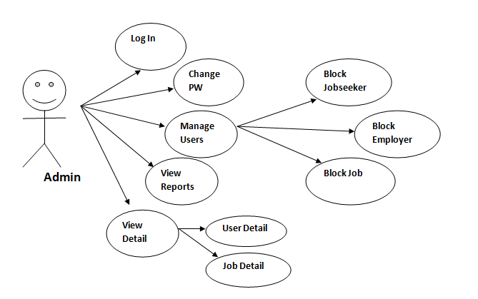

* Job Seeker(Use Case)

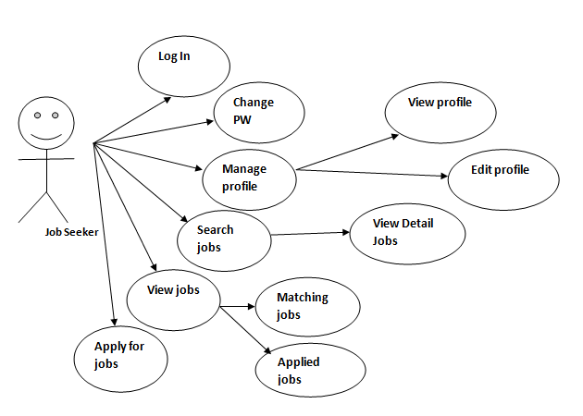

* Employer(Use Case)

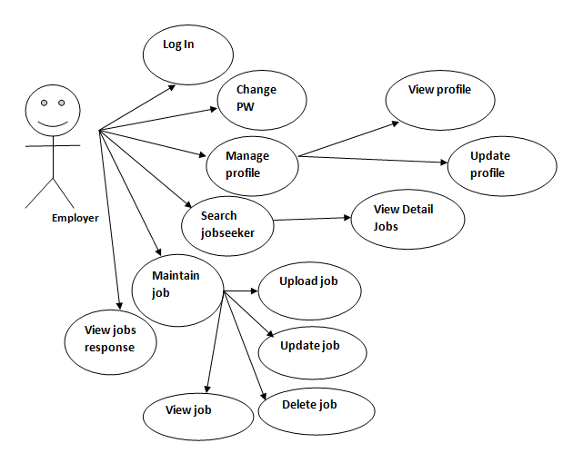

**Database Diagram**[4]

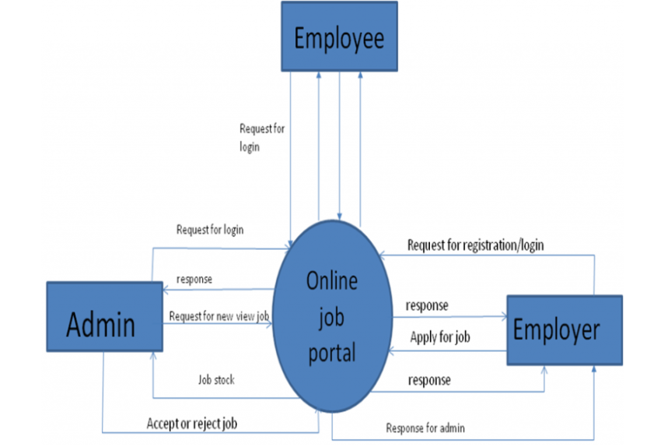

## 3.3 Project Schedule

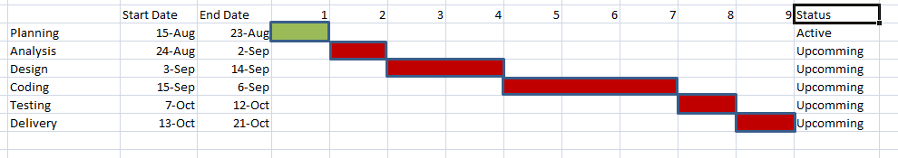

Fig : Gantt Chart

# Chapter 4 Conclusion

## Overall the management of job and the user will be done properly for the betterment of users. Job seekers can rely on this website to find the suitable jobs. They will also be given a proper feedback about choosing their job wisely. So, Hamro Job Centre Provides the better facilities for the job seekers

## 4.1 Expected Outcome

When the project is completed the users will be able to register the application form and search for job efficiently. They will be able to upload their resume, search their equivalent job and register for counseling.

# References

# Bibliography

|  |  |
| --- | --- |
| [1] | a tutorial points, "Simply Easy Learning," 2010. [Online]. Available: https://www.tutorialspoint.com/sdlc/sdlc_waterfall_model.htm#. |
| [2] | MBN, "Market Business News," 2015. [Online]. Available: https://marketbusinessnews.com/financial-glossary/feasibility-study/. |
| [3] | a tutorial points, "Simple Easy Learning," 2008. [Online]. Available: https://www.tutorialspoint.com/system_analysis_and_design/system_analysis_and_design_overview.htm. |
| [4] | N. P, "1000 PROJECTS," 22 AGUST 2017. [Online]. Available: https://1000projects.org/project-report-online-job-portal.html. |